Tomato Club Comprehensive Build Guide

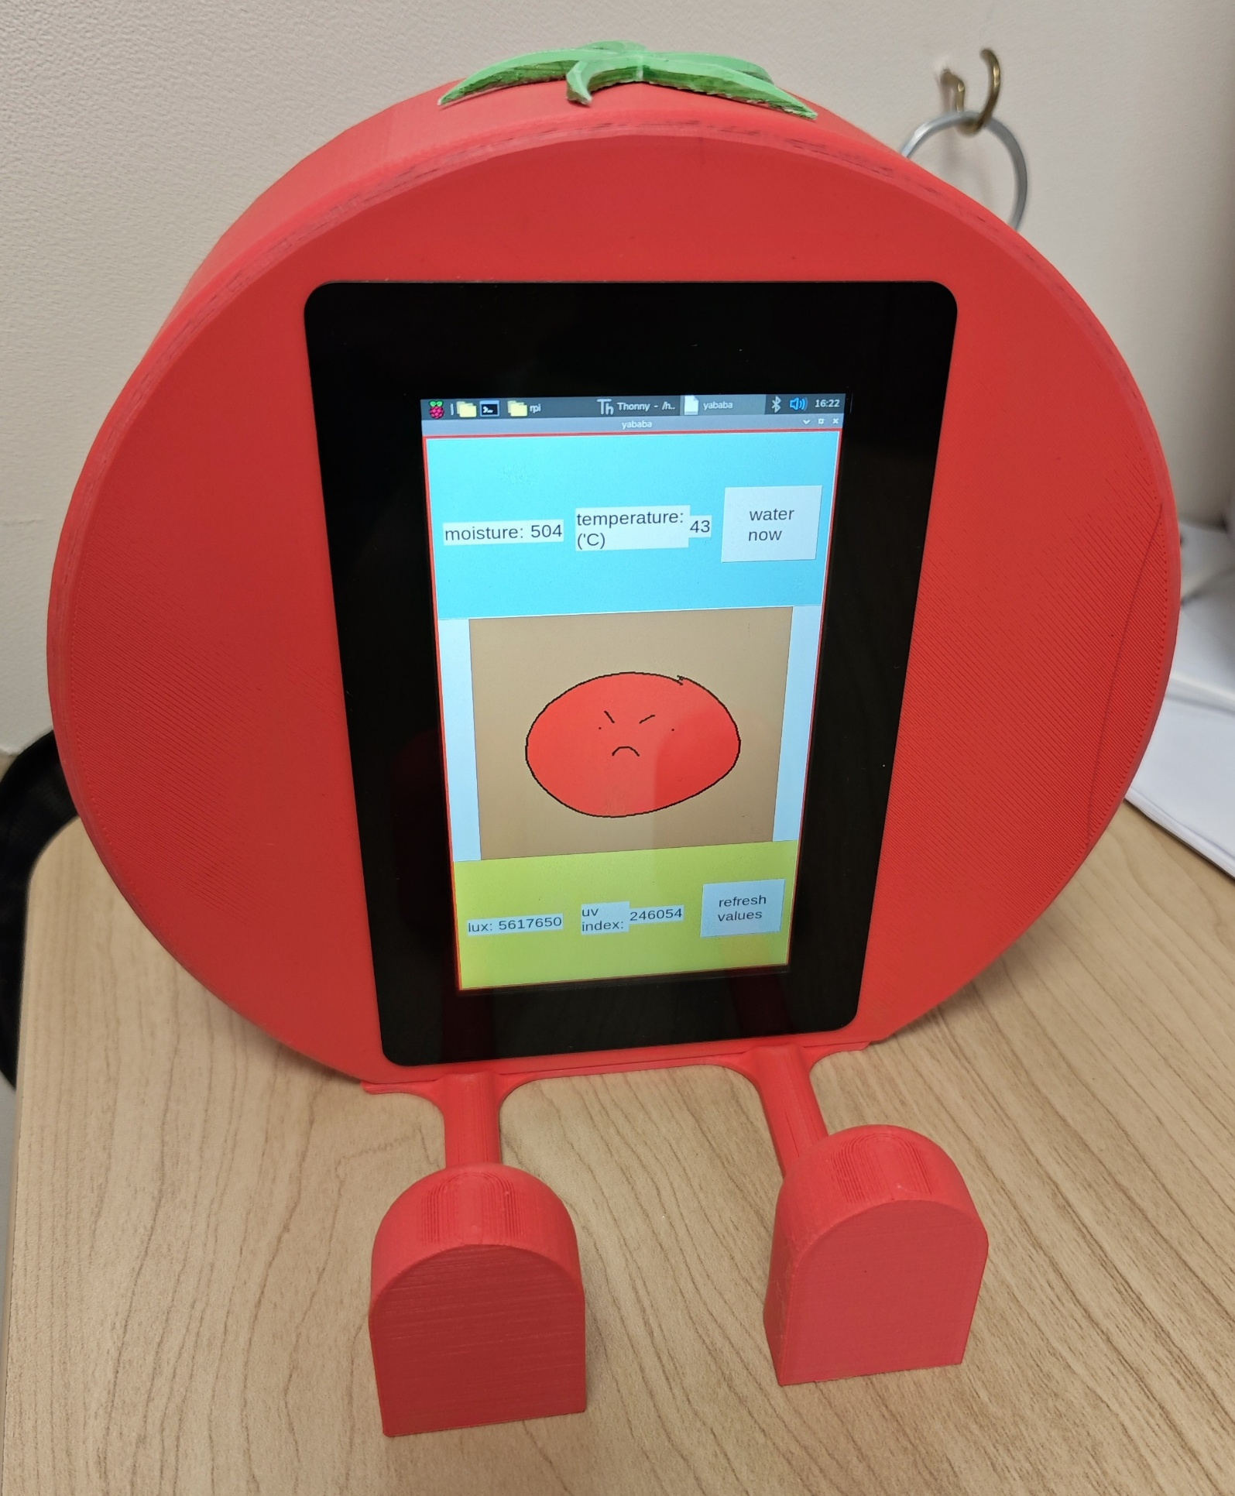

Things you should Know:
Male to Male wire: (Two pins)
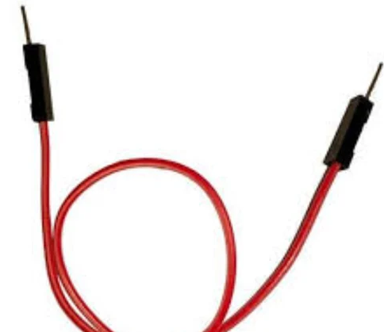
Male to female wire: (One Hole one pin)
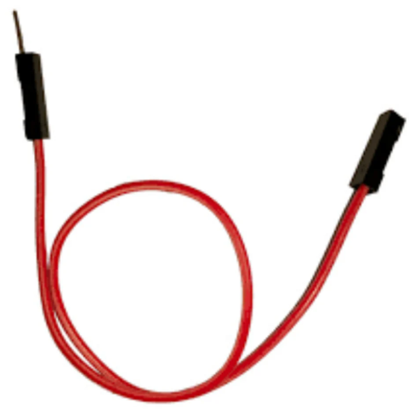
Female to female wire: (It has two holes)
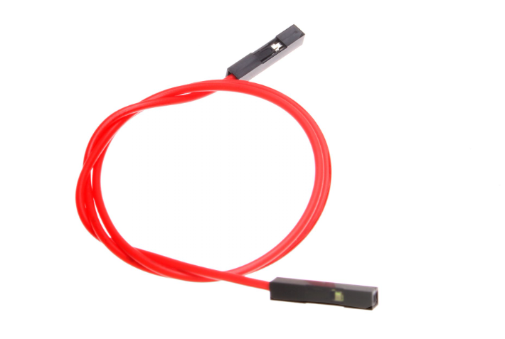
15way FFC (Flat Flex Cable) used for the screen:
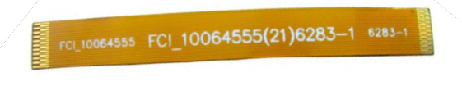

Step 1. Connect the pi to the Touch Display 2
- lift the retaining clip on the display output of the pi and then insert the 15-15way FFC, metal contacts facing up
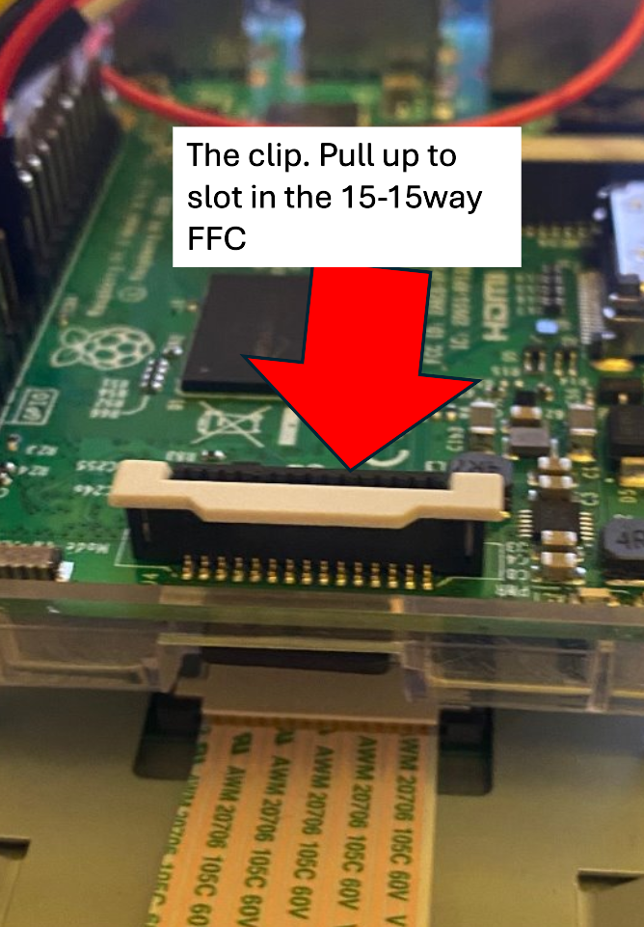

- Hold the FFC firmly in place and push the clip back down
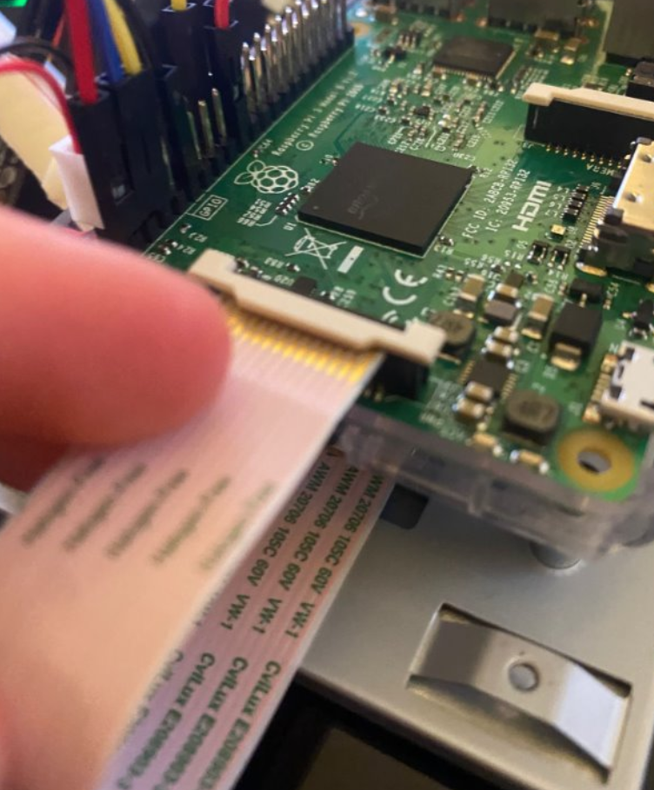

- Insert the other 15-way end of your FFC into the Touch screen 2 FFC connector, with the metal contacts facing upwards, away from the Touch Display 2.
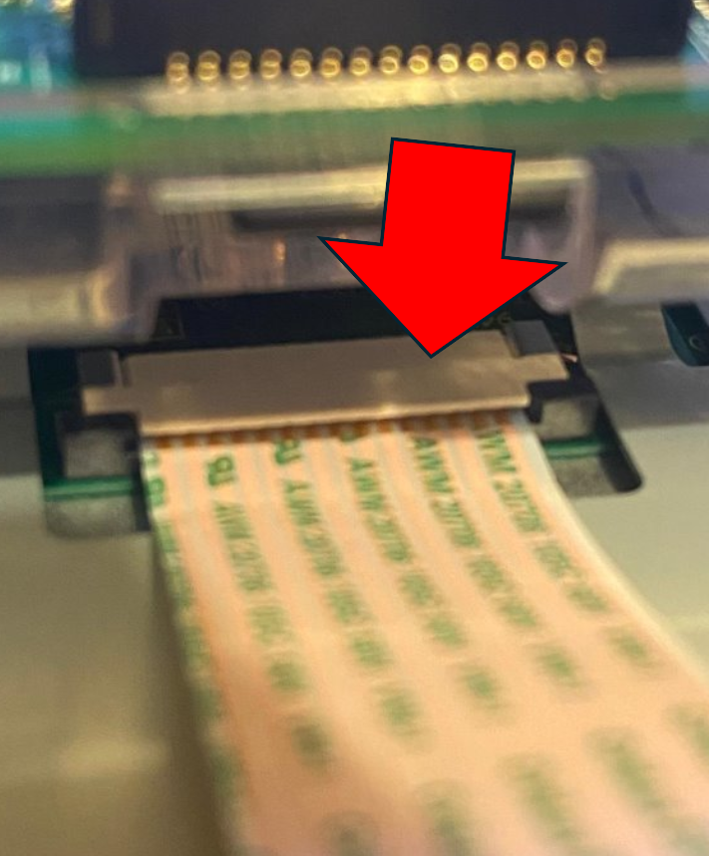

- Hold the FFC firmly in place and push the clip back down.
- screw the pi onto the back of the touch screen 2
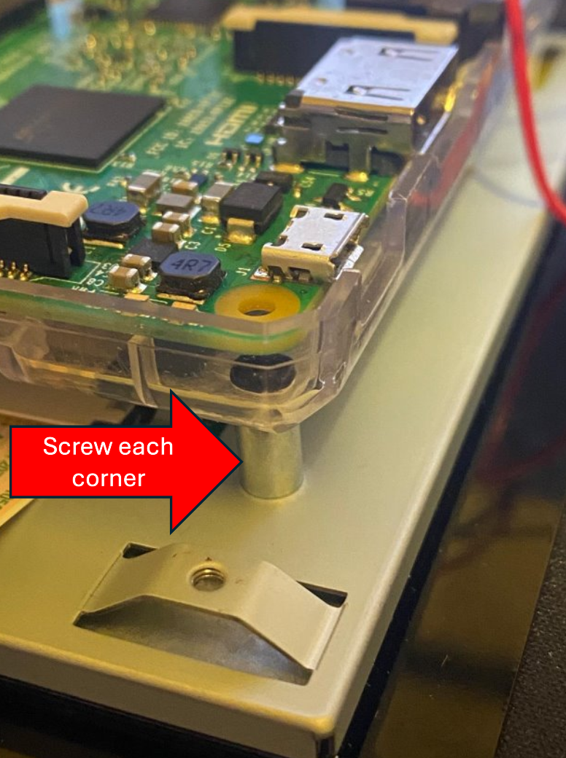

Step 2: The pump and relay:
- Plug one of the wires that comes off the pump into a ground pin and the other wire into the back of the relay. (the colours or which ground pin you plug it into don't matter)
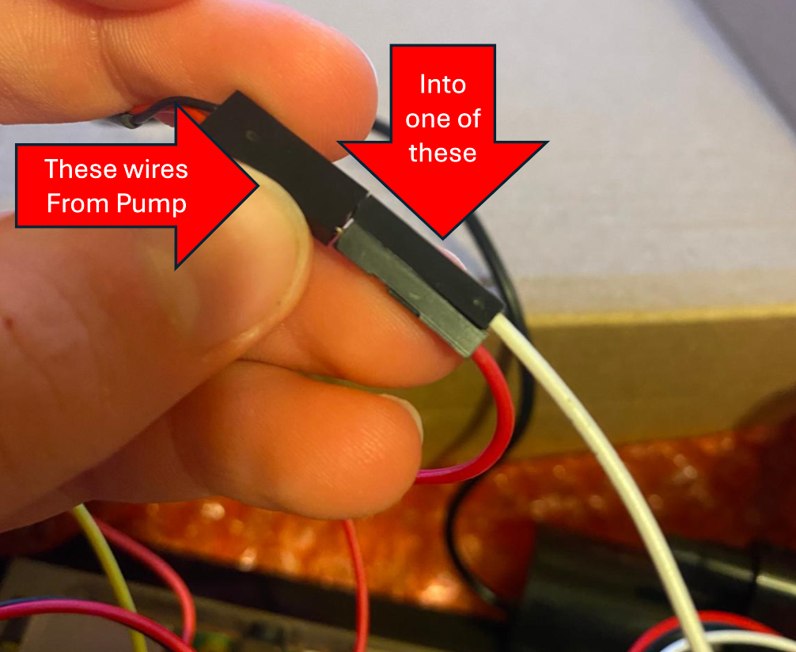
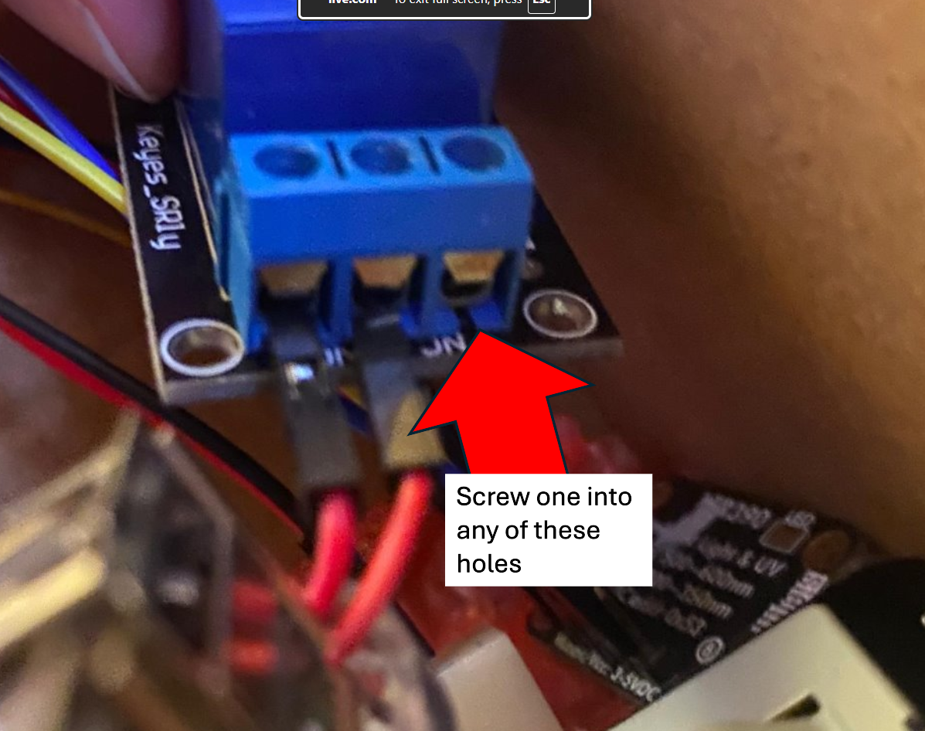
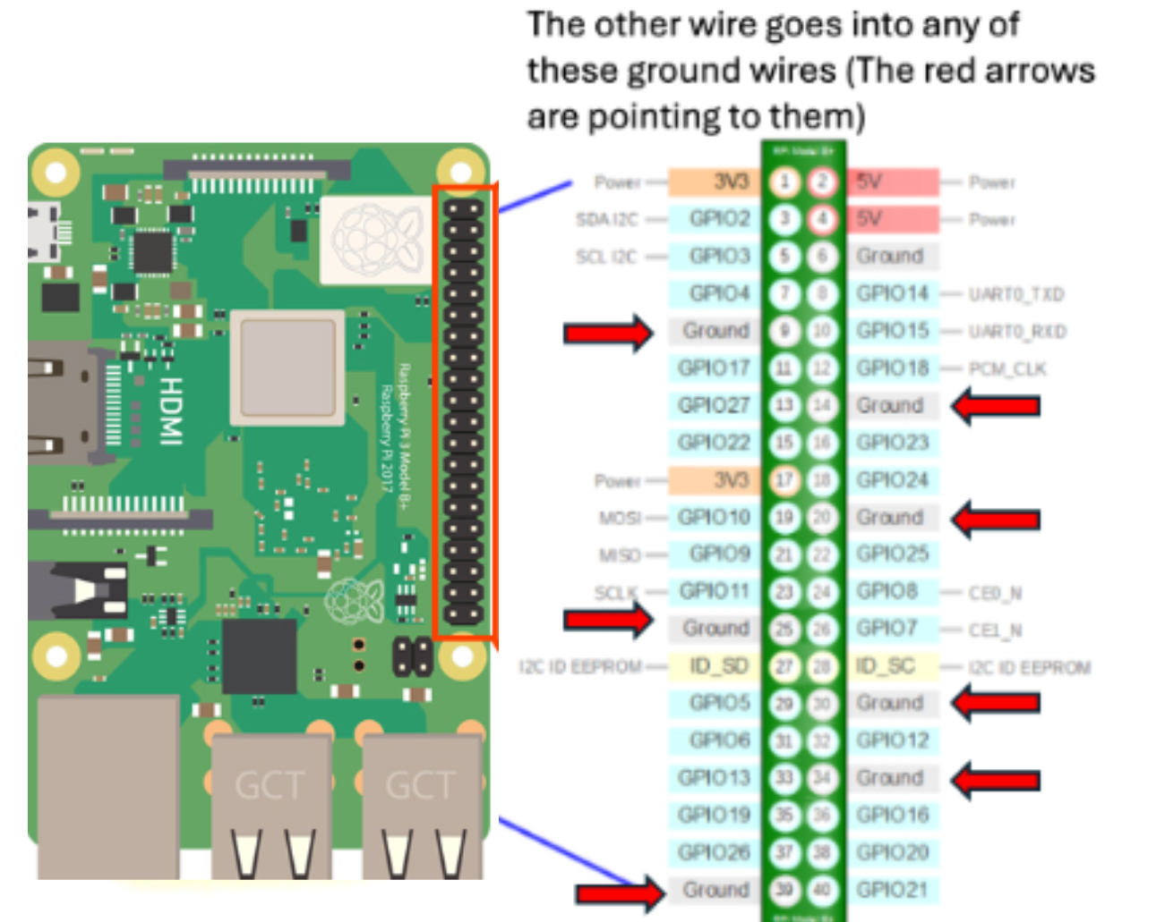
- Put the female end of a female-male wire into either the 3.5 volts or 5 volts on the pi and the male end into an empty port on the back of the relay. Note: male end must be screwed into the relay
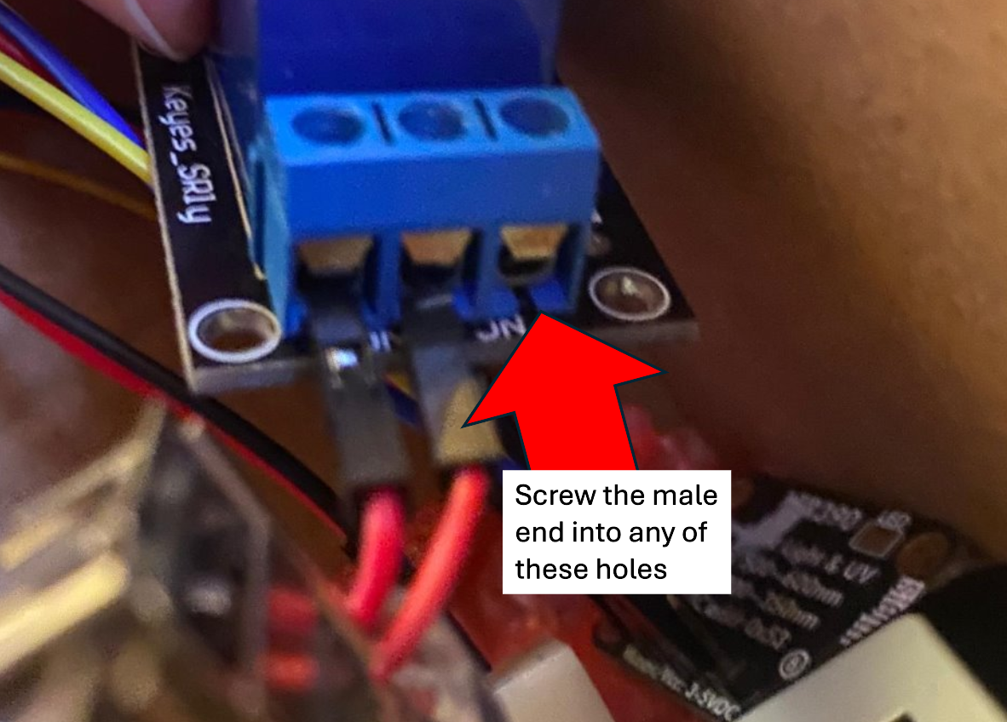
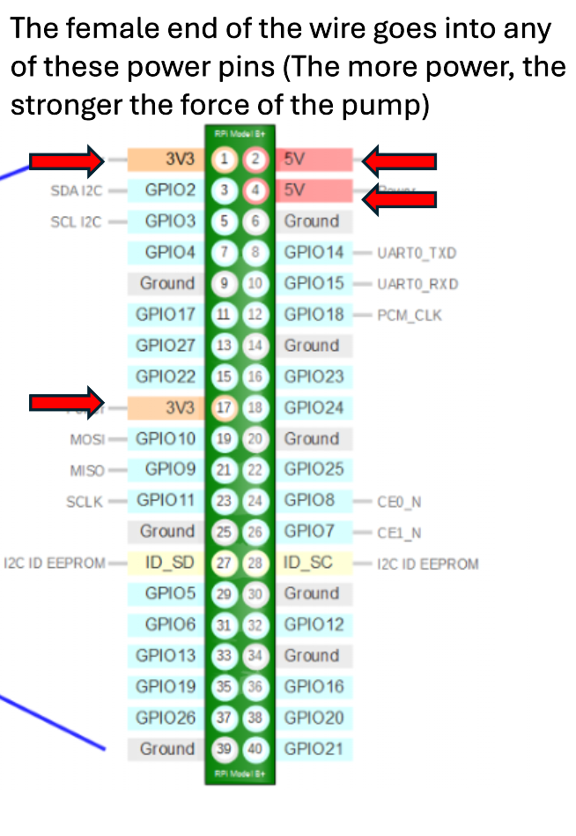

- Put a female-female wire into either 3.5 volts or 5 volts on the pi and the other end on the positive pin (plus marking) on the front of the relay.
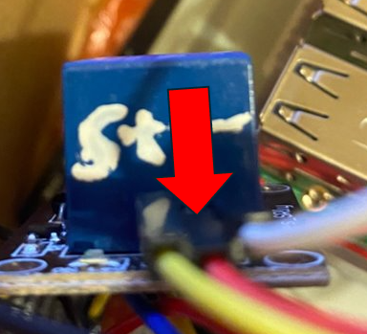

- Get a female-female wire and plug one of the female holes into a GPIO pin and the other female end into the signal pin in the relay.
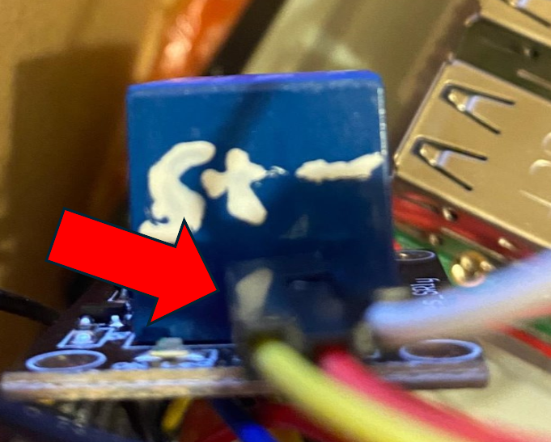
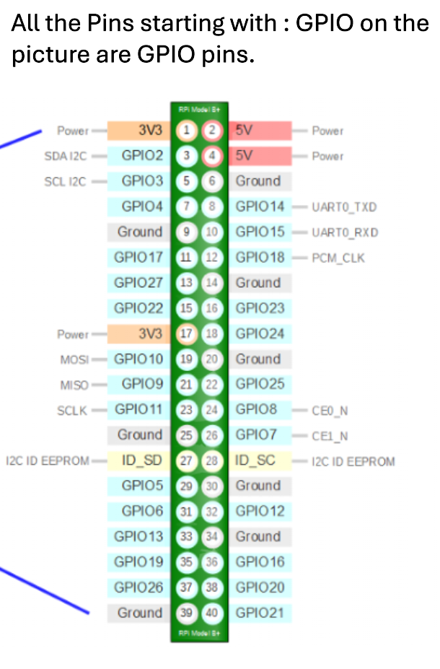

- Plug a ground wire into the negative pin in the relay.
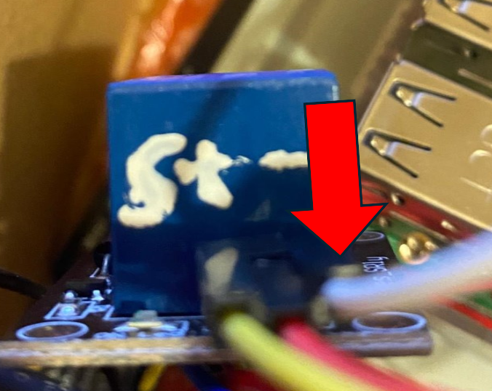
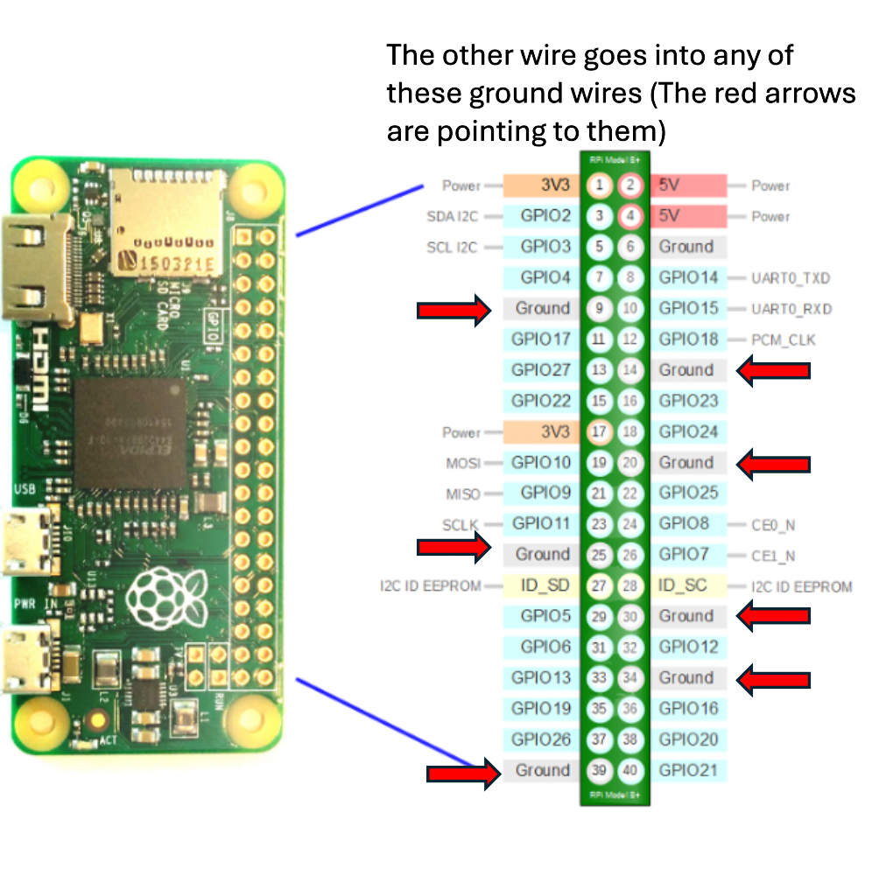
- The black part of the pump goes into the cup of water, and the tube will go over the plant.
Step 3: UV sensor:
Here's the Raspberry Pi wired to the sensor using I2C and a STEMMA QT connector:
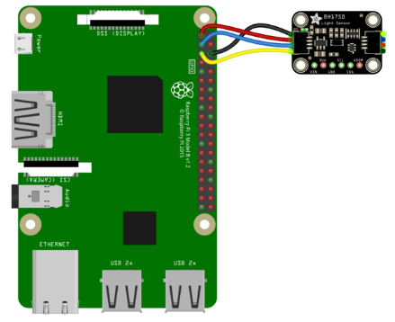
- Pi 3V to sensor VCC (red wire)
- Pi GND to sensor GND (black wire)
- Pi SCL to sensor SCL (yellow wire)
- Pi SDA to sensor SDA (blue wire)
- After you have wired the Light sensor, get a 4-pin connector with 4 wires with the opposites end being male.
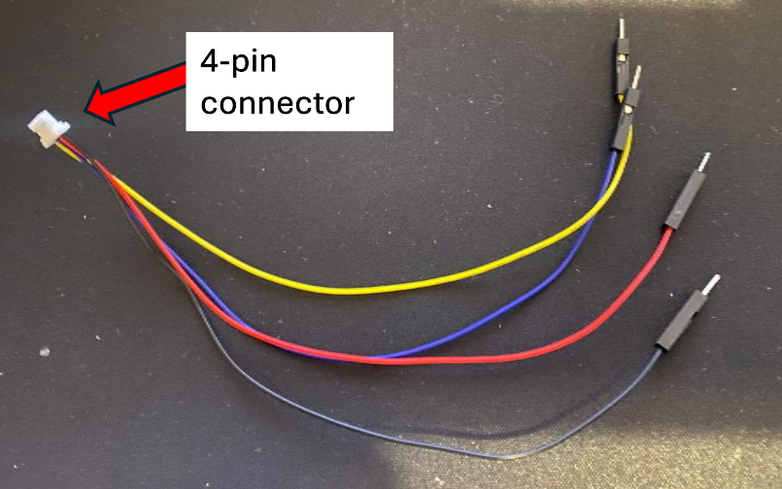
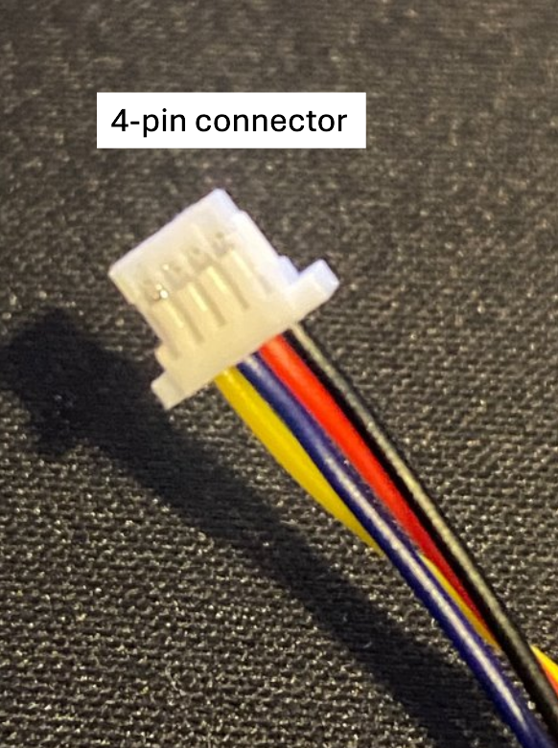
- After you have got these, plug the 4-pin connector into one of the ports on the side of the sensor.
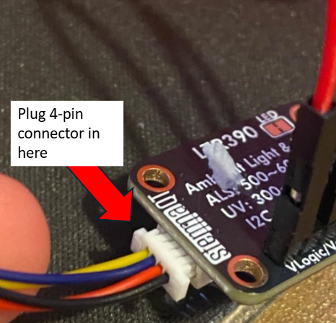
Leave this for now as we will continue it later.

Step 4: Moisture sensor:
We connected our moisture sensor through our Light sensor for added reach and less wiring.
1. Get another 4-pin connector (slightly larger) with 4 female ends.
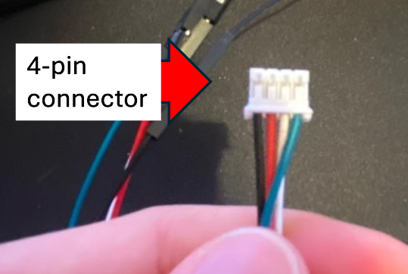
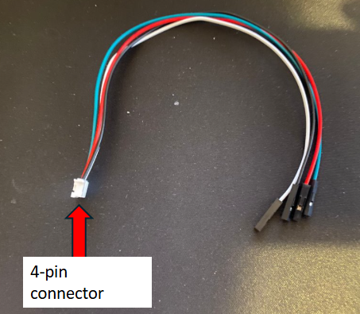

2. Next, plug the 4-pin connector into the moisture sensor.
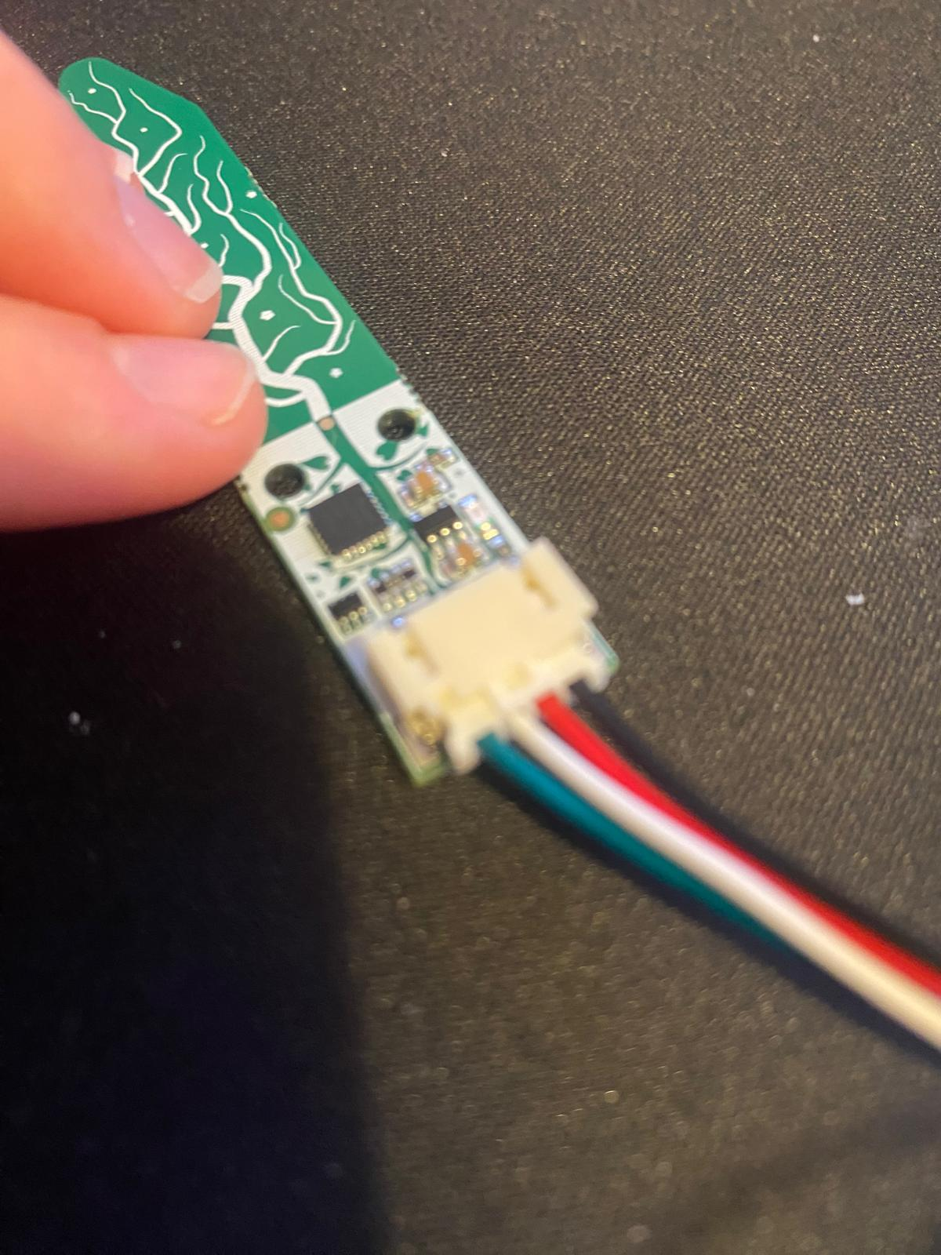
3. Get the four female ends and put them into the four male ends of the Light sensor.
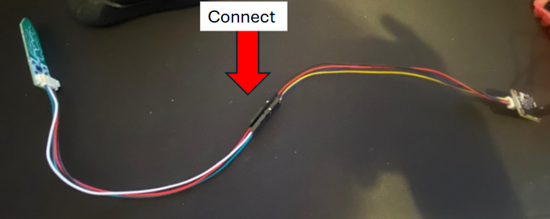

Step 5. print and assemble case:
- Create rough sketches of your desired outcome for the case on paper.
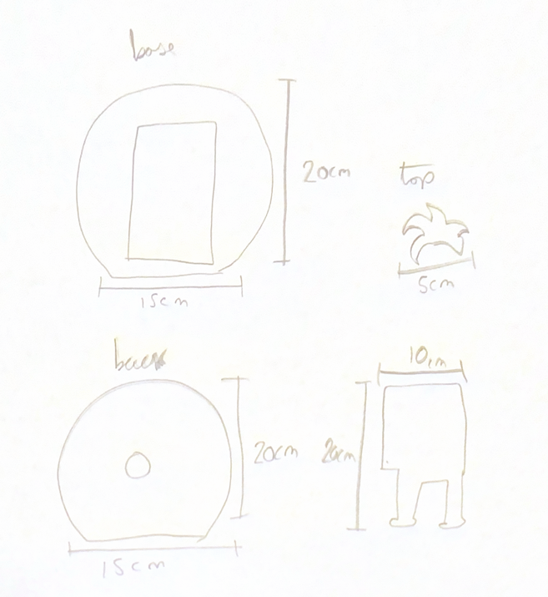
- Take all the measurements for the pi and make a list of the amount of space needed inside the case and the number of holes for wires and other hardware.
- After this, assess your final design and consider the measurements, practicality, size, and amount of filament used to make it.
- Then we used SolidWorks (other programs are available) to create your design in 3D. Make sure you refer to your measurements to ensure the sizing is correct.
- You can download our completed 3D files here
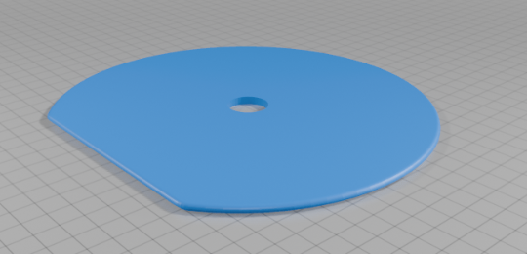
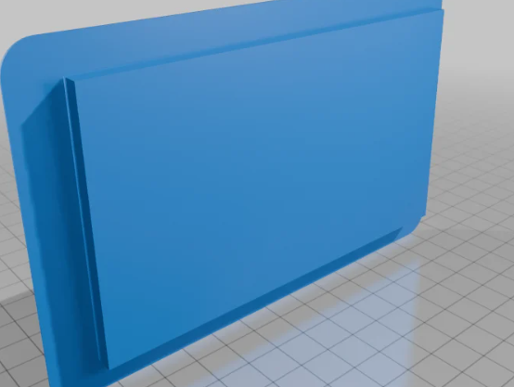
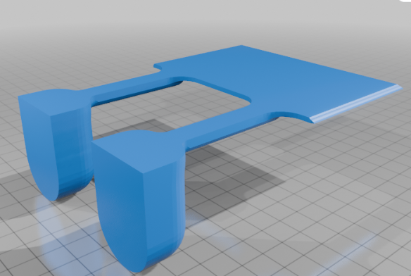
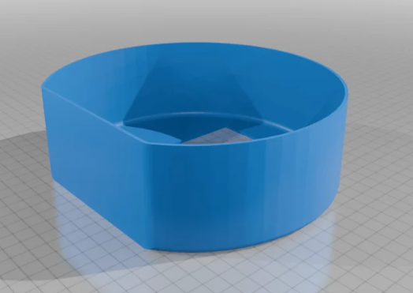

- Print your design on a 3D printer.
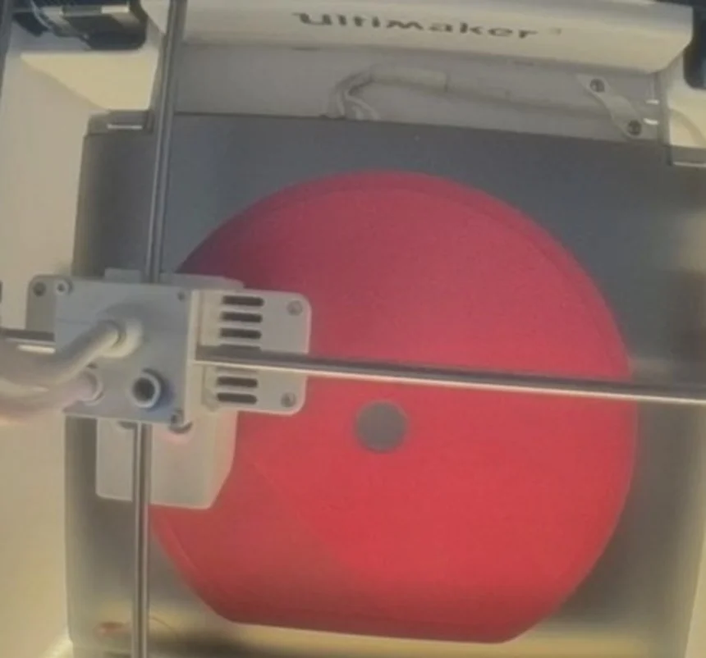

- Then you will have parts like this
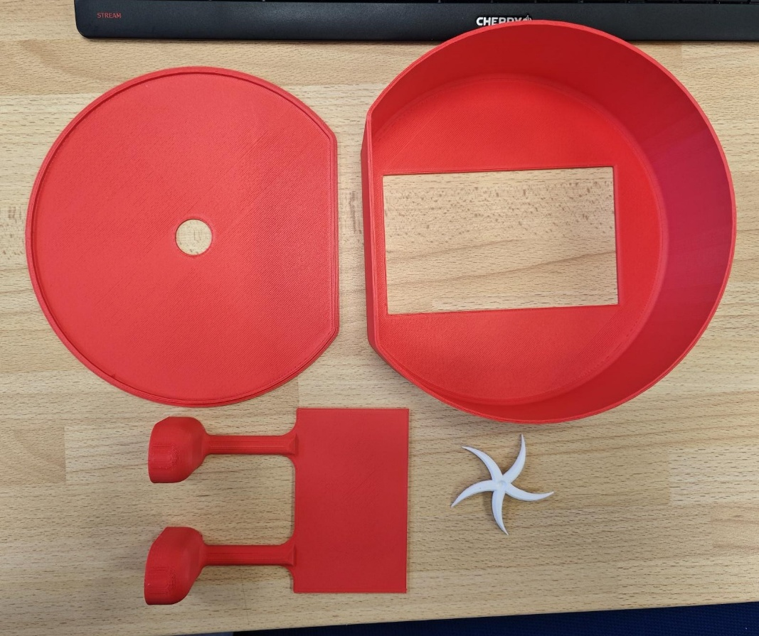

- Then assemble your final product. We used double-sided tape to stick all the parts together so they can easily be separated for safe transport.
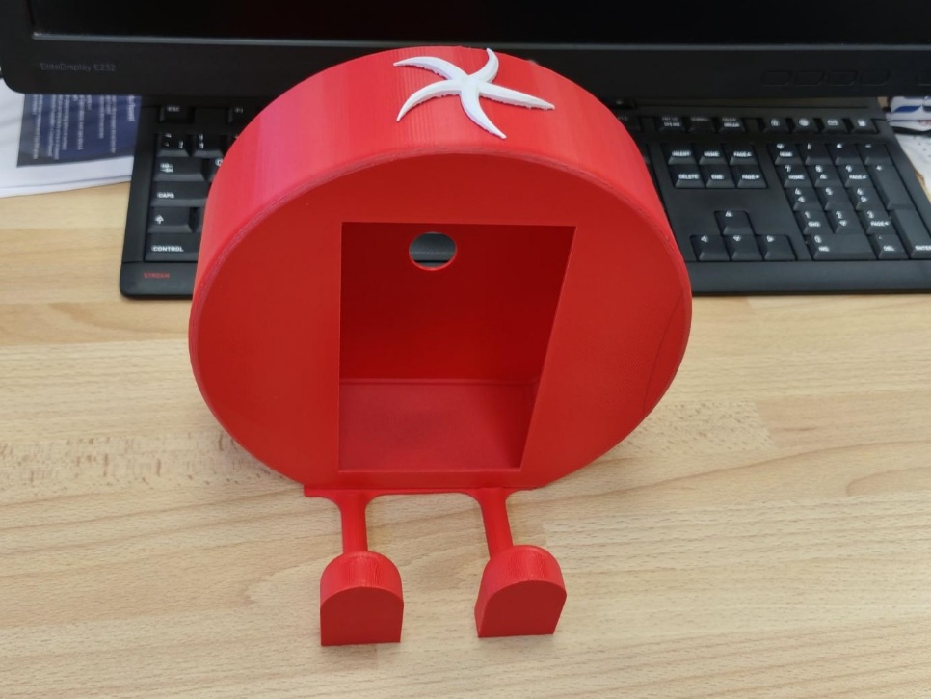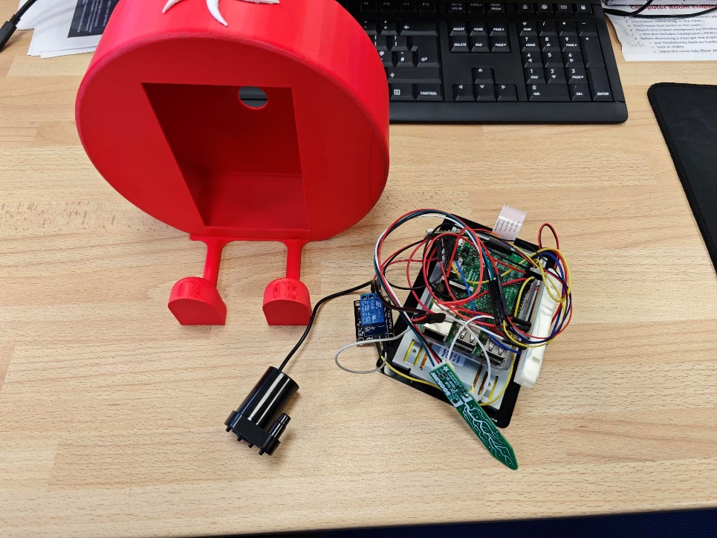

- Then insert the screen and stick it in with tape. The hole in the back of the case allows the power wire to go in and the wires going to the sensors and pump to go out.
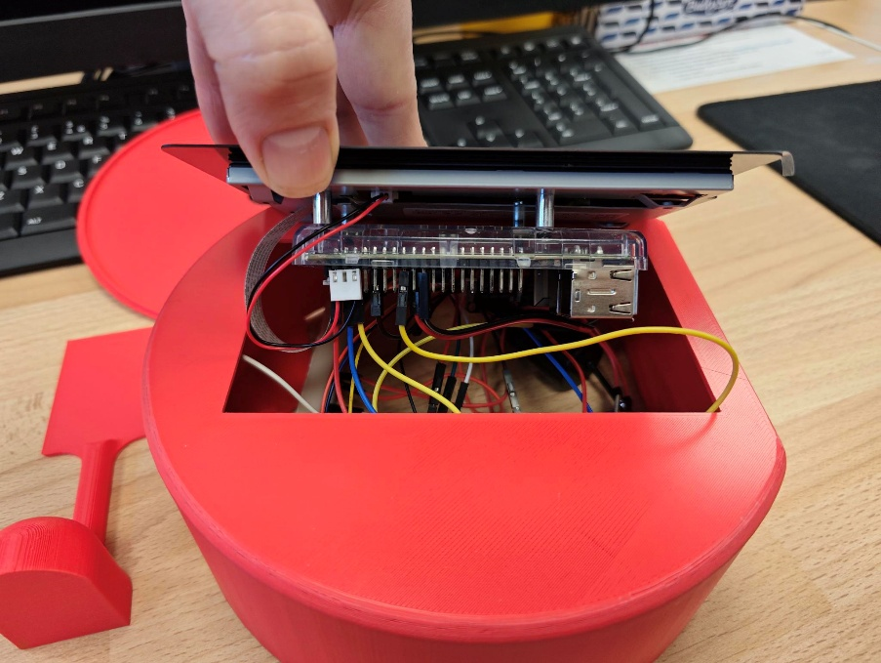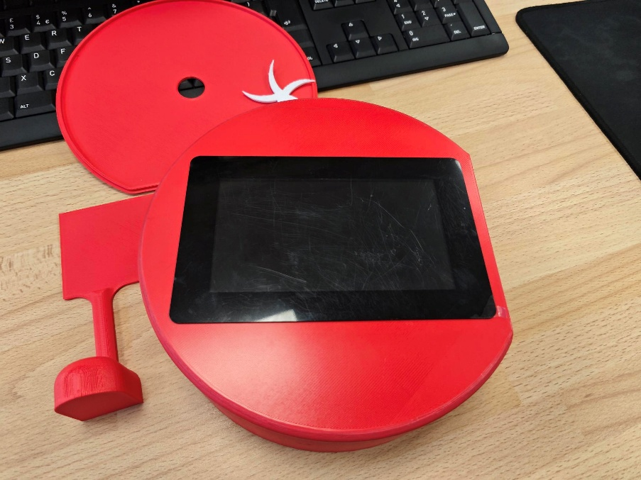
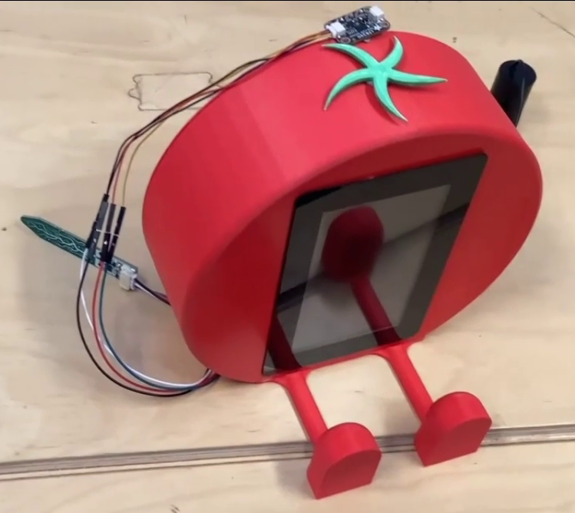
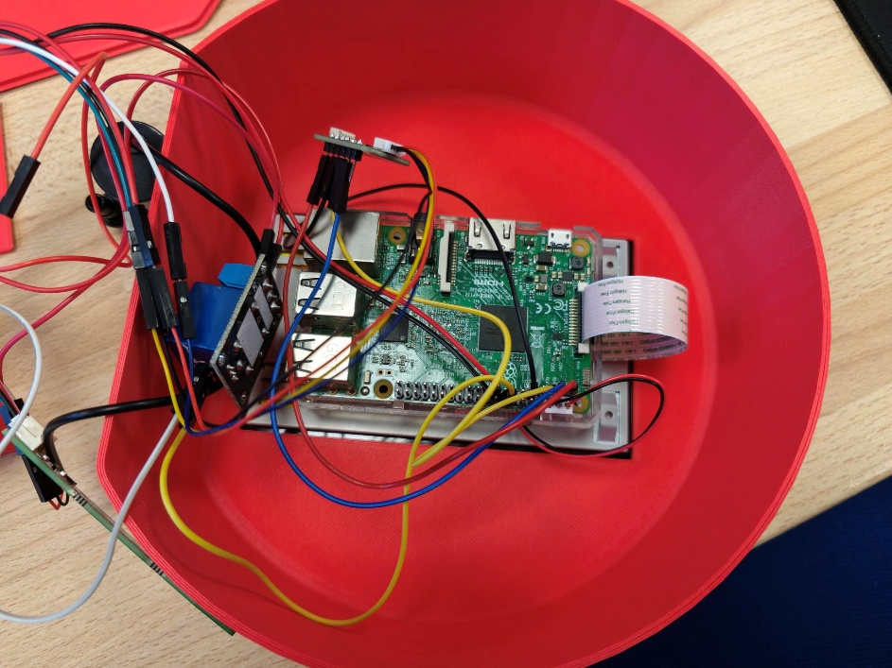
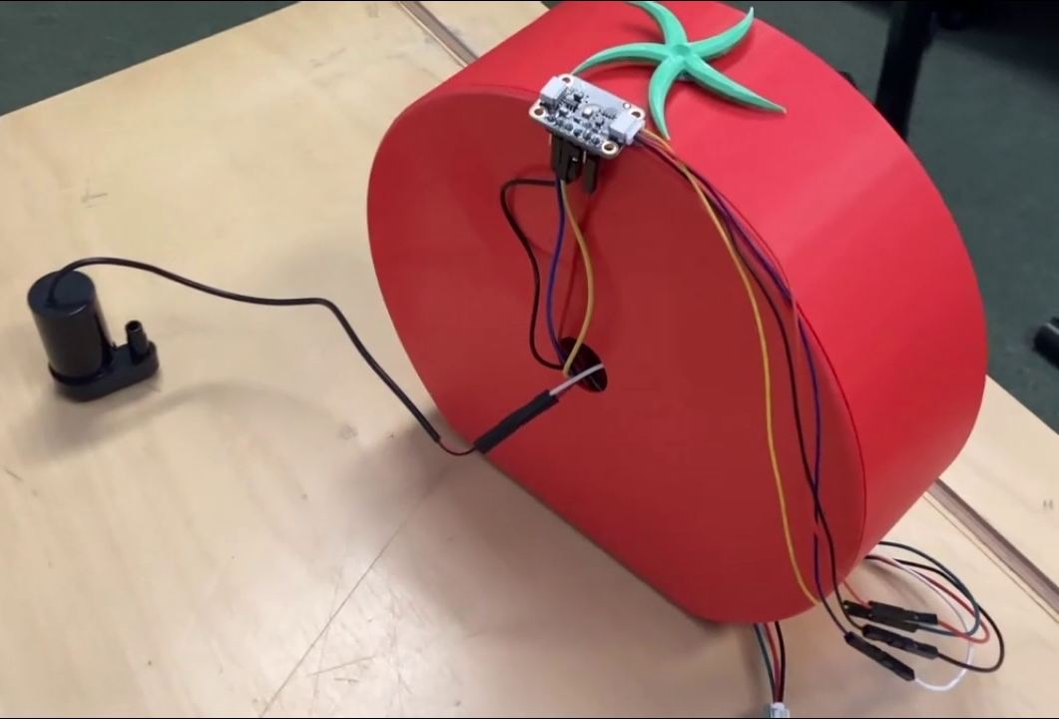

Step 6. Set up the software:
- Download the image files and python file from here.

- Copy them to your Raspberry pi in the same folder (/home/pi/ is a good location)

- Make them run automatically when the Pi turns on using this guide.

Step 7. Set up the sensors and pump:
- The light sensor needs to go somewhere near the plant, we put ours on top of the TomatoPi.
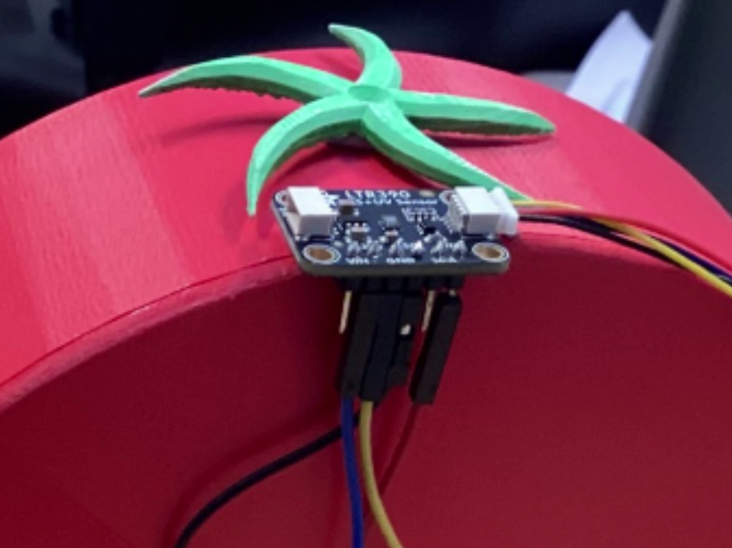
- The temperature and moisture sensor gets put into the plant pot
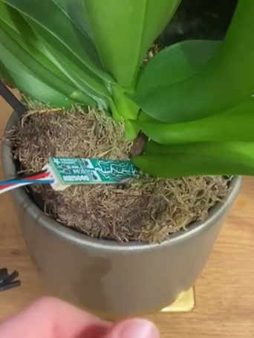
- The pump needs to go into a water container near the plant and the end of the tube goes into the plant pot.
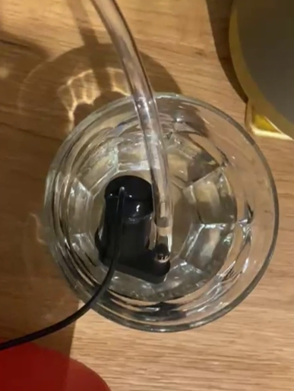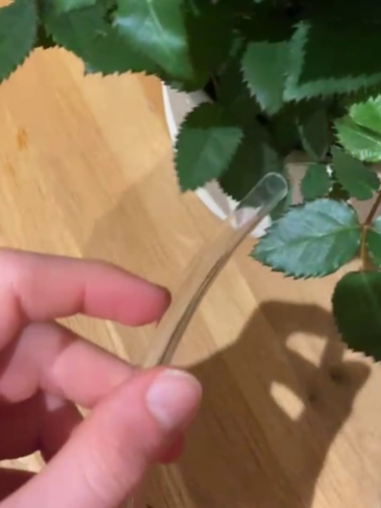
- The pump needs to go into a water container near the plant and the end of the tube goes into the plant pot.

Step 8. Test it:
- Depending on how warm, dry, and light the plant wants to be, you may need to change the numbers at the top of the Python program so that it shows a happy or sad face correctly and keeps the plant at the right moisture level.

- It will show a happy face when it is the right temperature, moistness and light level
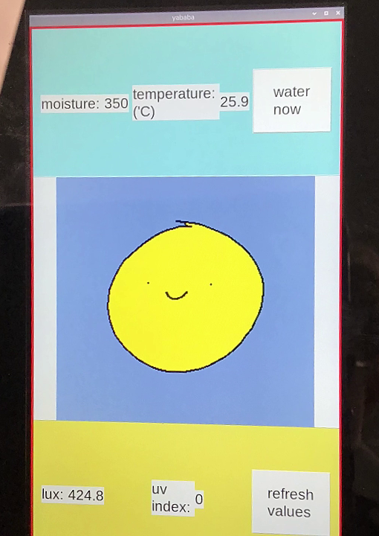

- It will show a sad face when one of those is not right.
